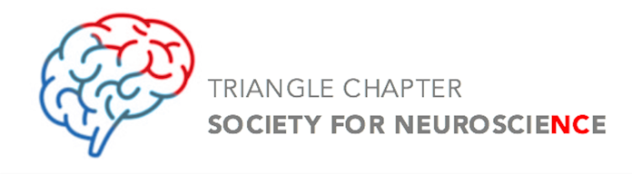
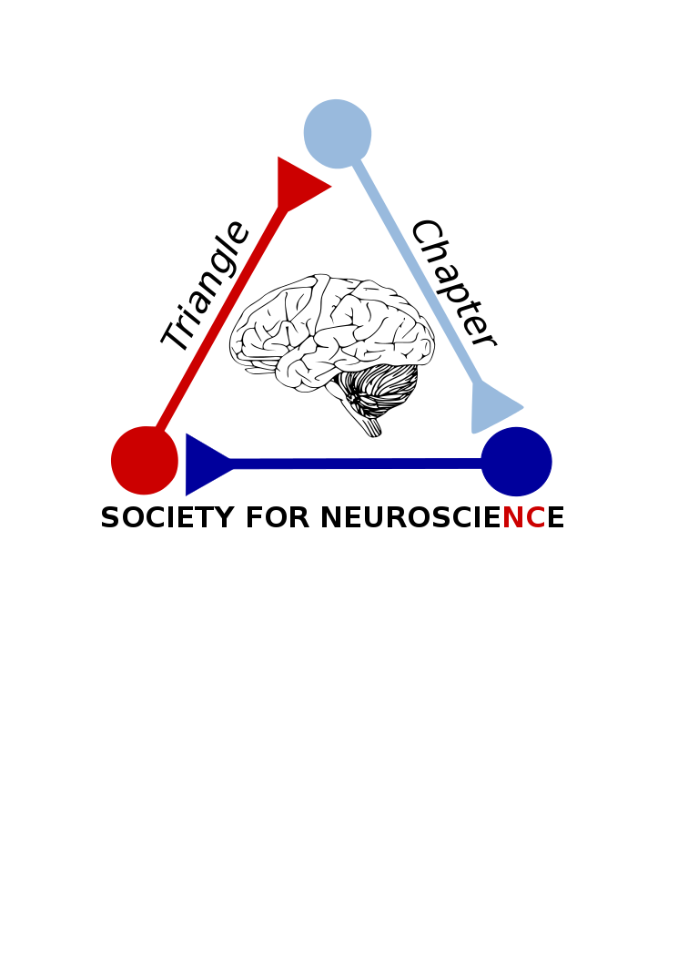

THE TRIANGLE

TRANSMITTER

February 2018
sMarch 10: Triangle Synapse Club, held in the Bryan Research Building at Duke University (5:15 pm)

March 14th: Neuroscience Trivia at Bull McCabes Irish Pub (ages 21+)

Welcome New Council Members!
Welcome New Council Members 1

SfN 2017 Annual Meeting Recap 2

Professional Development Workshop at SfN 2017 3

Triangle Brain Events 3

Science Policy Committee SfN 2017 4

Save the Date: Triangle SfN Spring Meeting 5

Spring Meeting 2018 Preview 6

Membership and Contact Information 7

The Triangle Transmitter is published by the Triangle Chapter of SfN.

Production Manager:
Deirdre Sackett

Chapter President
Dr. Patricia Jensen

President-Elect
Dr. John Meitzen

Chapter Representative
Deirdre Sackett

Secretary/Treasurer
Dr. Meghan Rebuli

The Triangle SfN Chapter is proud to announce its 2017-2018 council members! Council members attend monthly chapter meetings, help to organize regional chapter events, and participate on chapter committee boards. These annually-elected positions are essential to our chapter’s success! Welcome to our 7 amazing members!
Triangle SfN Chapter
2017 – 2018 Council Members

Leslie Wilson
Graduate Student, NCSU

Dr. Eric Bauer
Assistant Professor of Biology, Elon U

Dr. Antoniette Maldonado-Devincci
Assistant Professor of Psychology, NC A&T

Rachel Haake
Graduate Student, UNC-CH

Dr. Ju-Ahng Lee
Assistant Professor of Biological and Biomedical Sciences, NCCU

Deirdre Sackett
Graduate Student, UNC-CH

Kylie Rock
Graduate Student, NCSU

Looking forward to a great year!

- Deirdre Sackett (UNC-CH)

Society for Neuroscience Annual Meeting 2017

Washington, D.C.
The annual Society for Neuroscience 2017 meeting was held November 11-15 at the Walter E. Washington Convention Center in Washington, D.C. The program was filled with neuroscience content that encompassed workshops, lectures, mini-symposia, as well as SfN-sponsored socials and events. This year, more than 30,000 scientists attended and the conference featured over 15,000 poster presentations.
Additionally, there were 740 exhibitors who showcased new ideas, technology, and publishing opportunities. Posters presentations were organized into topically-based sessions/nanosymposia with a few posters designated as dynamic posters. The poster sessions covered a vast range of topics, including neuronal development, neurodegenerative disorders, injury, cognition, and more. Posters were displayed each morning and afternoon.
The Triangle SfN Chapter had a great turn out at this international conference! In this issue of the Triangle Transmitter there are articles describing some of our chapter’s contributions to the conference including discussions we had with Senator Thom Tillis and Congressman G.K. Butterfield as well as our own panel discussion held by Dr. John Meitzen (NCSU).
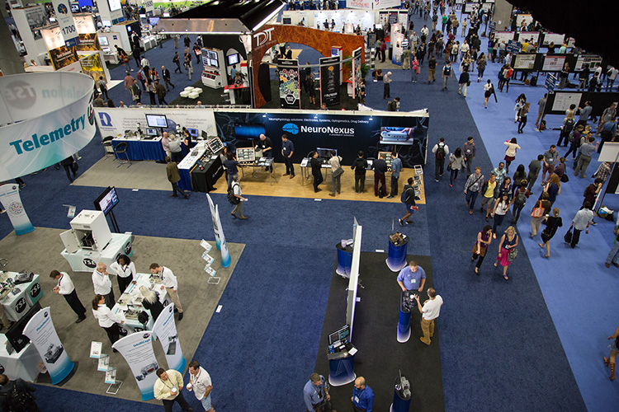
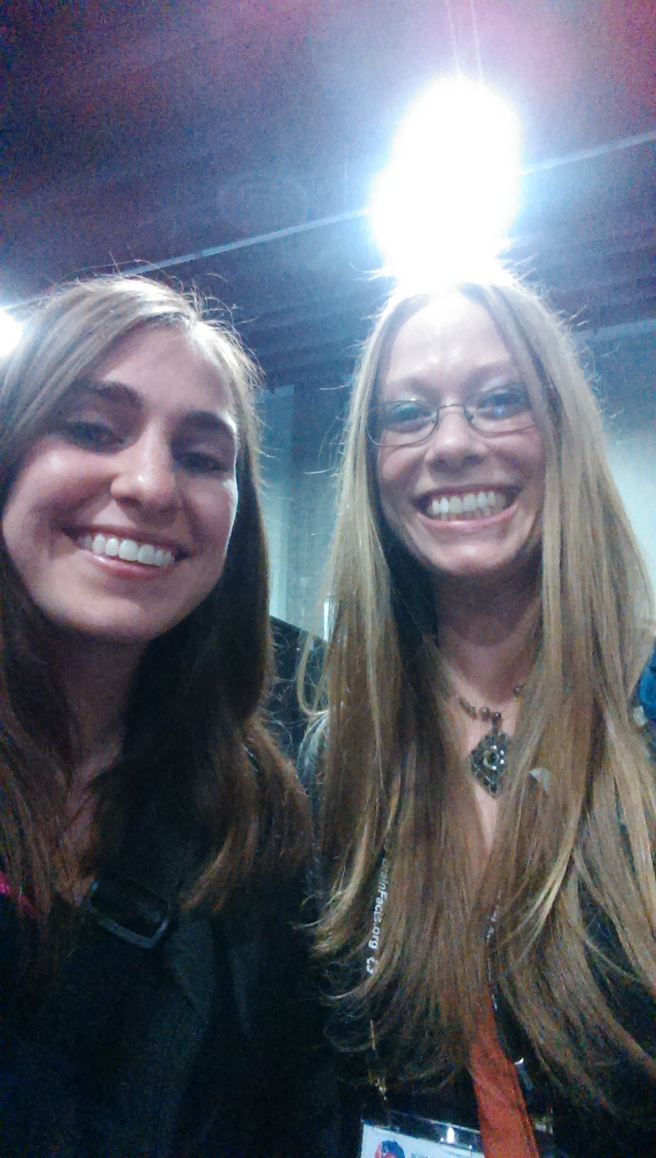
We were glad to see so many members from the Triangle SfN Chapter at this conference and look forward to seeing everyone again next year!
Left: Society for Neuroscience attendees roam about the exhibit and poster hall. More than 30,000 scientists attended this year’s conference! Photo credit: Leslie Wilson (NCSU).
Right: Triangle SfN council members Rachel Haake (left, UNC-CH) and Christina Lebonville (right, UNC-CH) are all smiles at Society for Neuroscience 2017! Photo credit: Christina Lebonville (UNC-CH).
- Leslie Wilson, NCSU

SfN 2017: Professional Development Workshop
Triangle Chapter members Dr. John Meitzen (NCSU), and Christina Lebonville (UNC-CH) organized and participated in a Professional Development Workshop at the 2017 Society for Neuroscience meeting in Washington D.C. The title of the workshop was “Incorporating Public Engagement into Your Professional Portfolio: A Practical Guide.” Its premise was that engagement is hugely rewarding for both individual neuroscientists and our field as a whole, yet it can be challenging to effectively organize and perform.
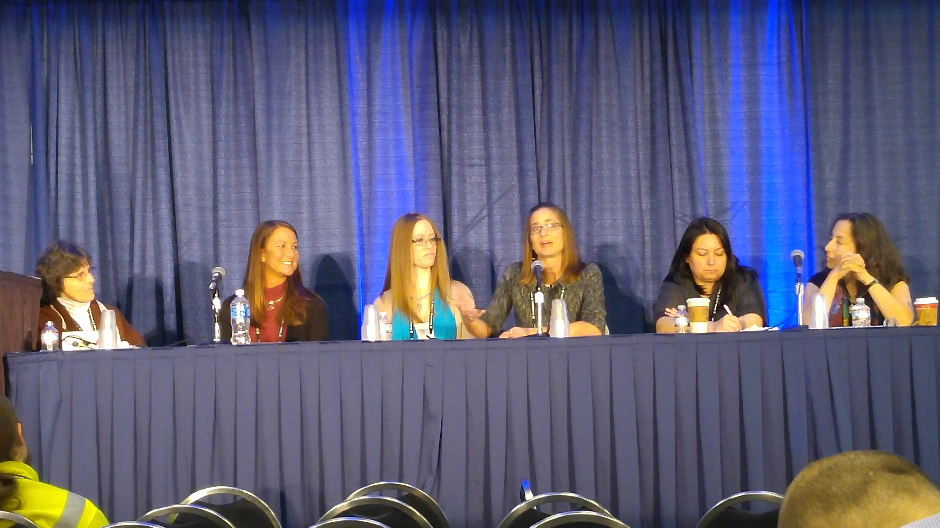
The workshop offered resources and hard-won perspectives for how to incorporate meaningful neuroscience public engagement into a professional portfolio, without sacrificing other responsibilities. Six panelists made brief presentations: Dr. Janet Dubinsky (U. of Minnesota), Dr. Nicole Banganz (Florida Atlantic University), Christina Lebonville (UNC-CH), Dr. Kyle Frantz (Georgia State U.), Dr. Diasynou Fioravante (UC Davis), and Dr. Martha Farah (U. of Pennsylvania). Dr. John Meitzen (NCSU) moderated the workshop. The panelists then offered an interactive forum to help audience members apply best practices. Over 100 people attended the workshop, and feedback has been overwhelmingly positive.
Six panelists (including council member Christina Lebonville, third from left) participated in the Professional Development Workshop. Photo credit: Dr. John Meitzen (NCSU).
The Society for Neuroscience will turn the workshop into a webinar, which is anticipated to be available for viewing in 2018.
- Dr. John Meitzen (NCSU)

Mark Your Calendars!

Science Café: Brain and Behavior Night

March 15, 2018
NRC Building, NC Museum of Natural Sciences
11 W Jones St, Raleigh, NC 27601
6 - 8:30 PM

From flies to humans, brains make behavior happen. Come explore this at a special Science Cafe! From 6 - 7 PM, meet local neuroscientists and interact with hands-on exhibits suitable for all ages. Short, accessible talks by neuroscientists in the Daily Planet will celebrate national Brain Awareness Week and tell you what local neuroscientists are discovering. At 7 PM, neuroscientist Dr. Jeff Lichtman from Harvard University will lead a Science Café. Afterwards, the exhibits will re-open for one final celebration of brain and behavior.

DIBS Discovery Day

April 15, 2018
DIBS Cube, Levine Science Research Center
308 Research Drive, Durham, NC, 27708
1 - 4 PM

Join the Duke Institute for Brain Sciences (DIBS) for DIBS Discovery Day! Enjoy a hands-on, family friendly event highlighting some of the work in and around DIBS, including the Bass Connections in Brain and Society projects and other interactive exhibits. Discover how brain science is used to help solve society’s most pressing challenges.

DIBS Discovery Day is free and open to the public.

Science Policy at SfN 2017

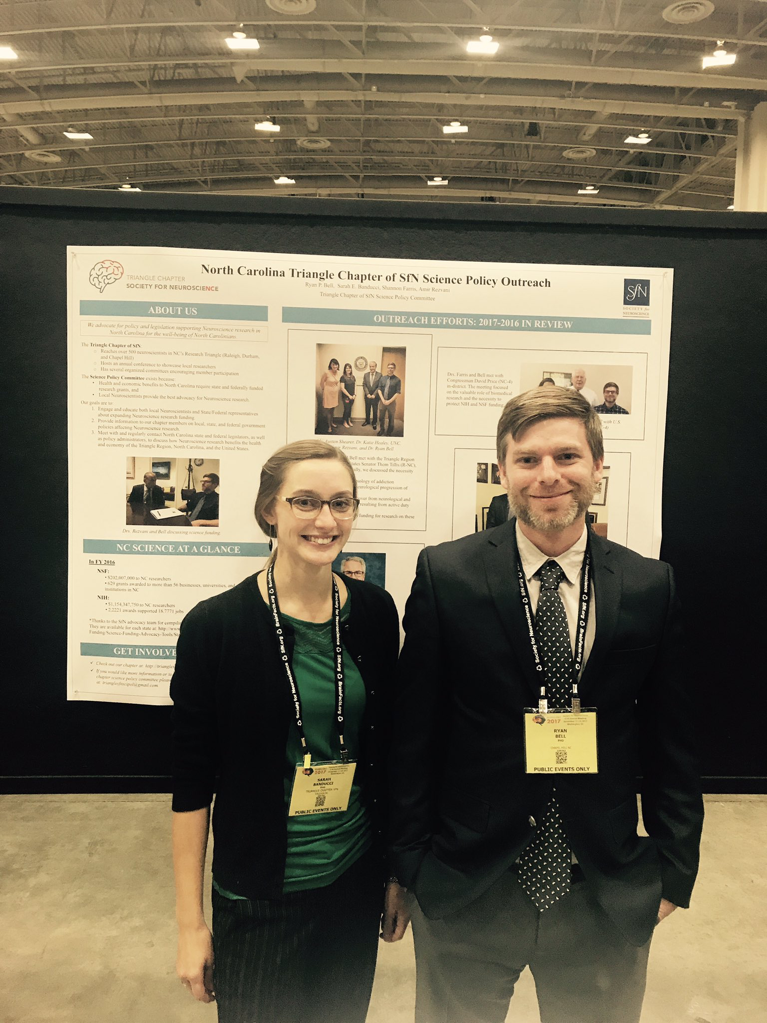
Members of the Triangle Chapter of the Society for Neuroscience joined more than 30,000 scientists at SfN’s 47th annual conference from November 11-15 in Washington, D.C. An advocacy reception showcased efforts made by chapters nationwide to engage their communities and policy makers. The Triangle Chapter’s Science Policy Committee presented a poster at the reception on their activities over the previous year including meetings with state and federal legislators and local science policy administrators.
While in Washington D.C., Science Policy Committee Co-Chairs Drs. Ryan Bell and Sarah Banducci met with NC U.S. Senator Thom Tillis’s health policy staff member, David Simons and NC U.S Representative George “G.K.” Butterfield Jr’s (NC-01) staff member, Edward Hill at their respective Congressional offices. These meetings primarily consisted of advocating for support of NIH and NSF funding for the Triangle Region, sharing our member’s experiences to convey the importance of this funding to scientific breakthroughs across a wide range of topics. Both offices expressed support for the significance of scientific funding to the health and economy of The State of North Carolina and United States. We were also able to introduce the Triangle Chapter’s members as possible sources of information for legislation involving Neuroscience research.
If you are interested in becoming involved or hearing more about the Science Policy Committee please contact us at trianglesfnscipol@gmail.com.
- Dr. Ryan Bell (Duke)
Science Policy Committee Co-Chairs Dr. Sarah Banducci (left) and Dr. Ryan Bell (right, Duke) presented a poster detailing the chapter’s annual policy outreach events. Photo credit: Dr. Ryan Bell (Duke).

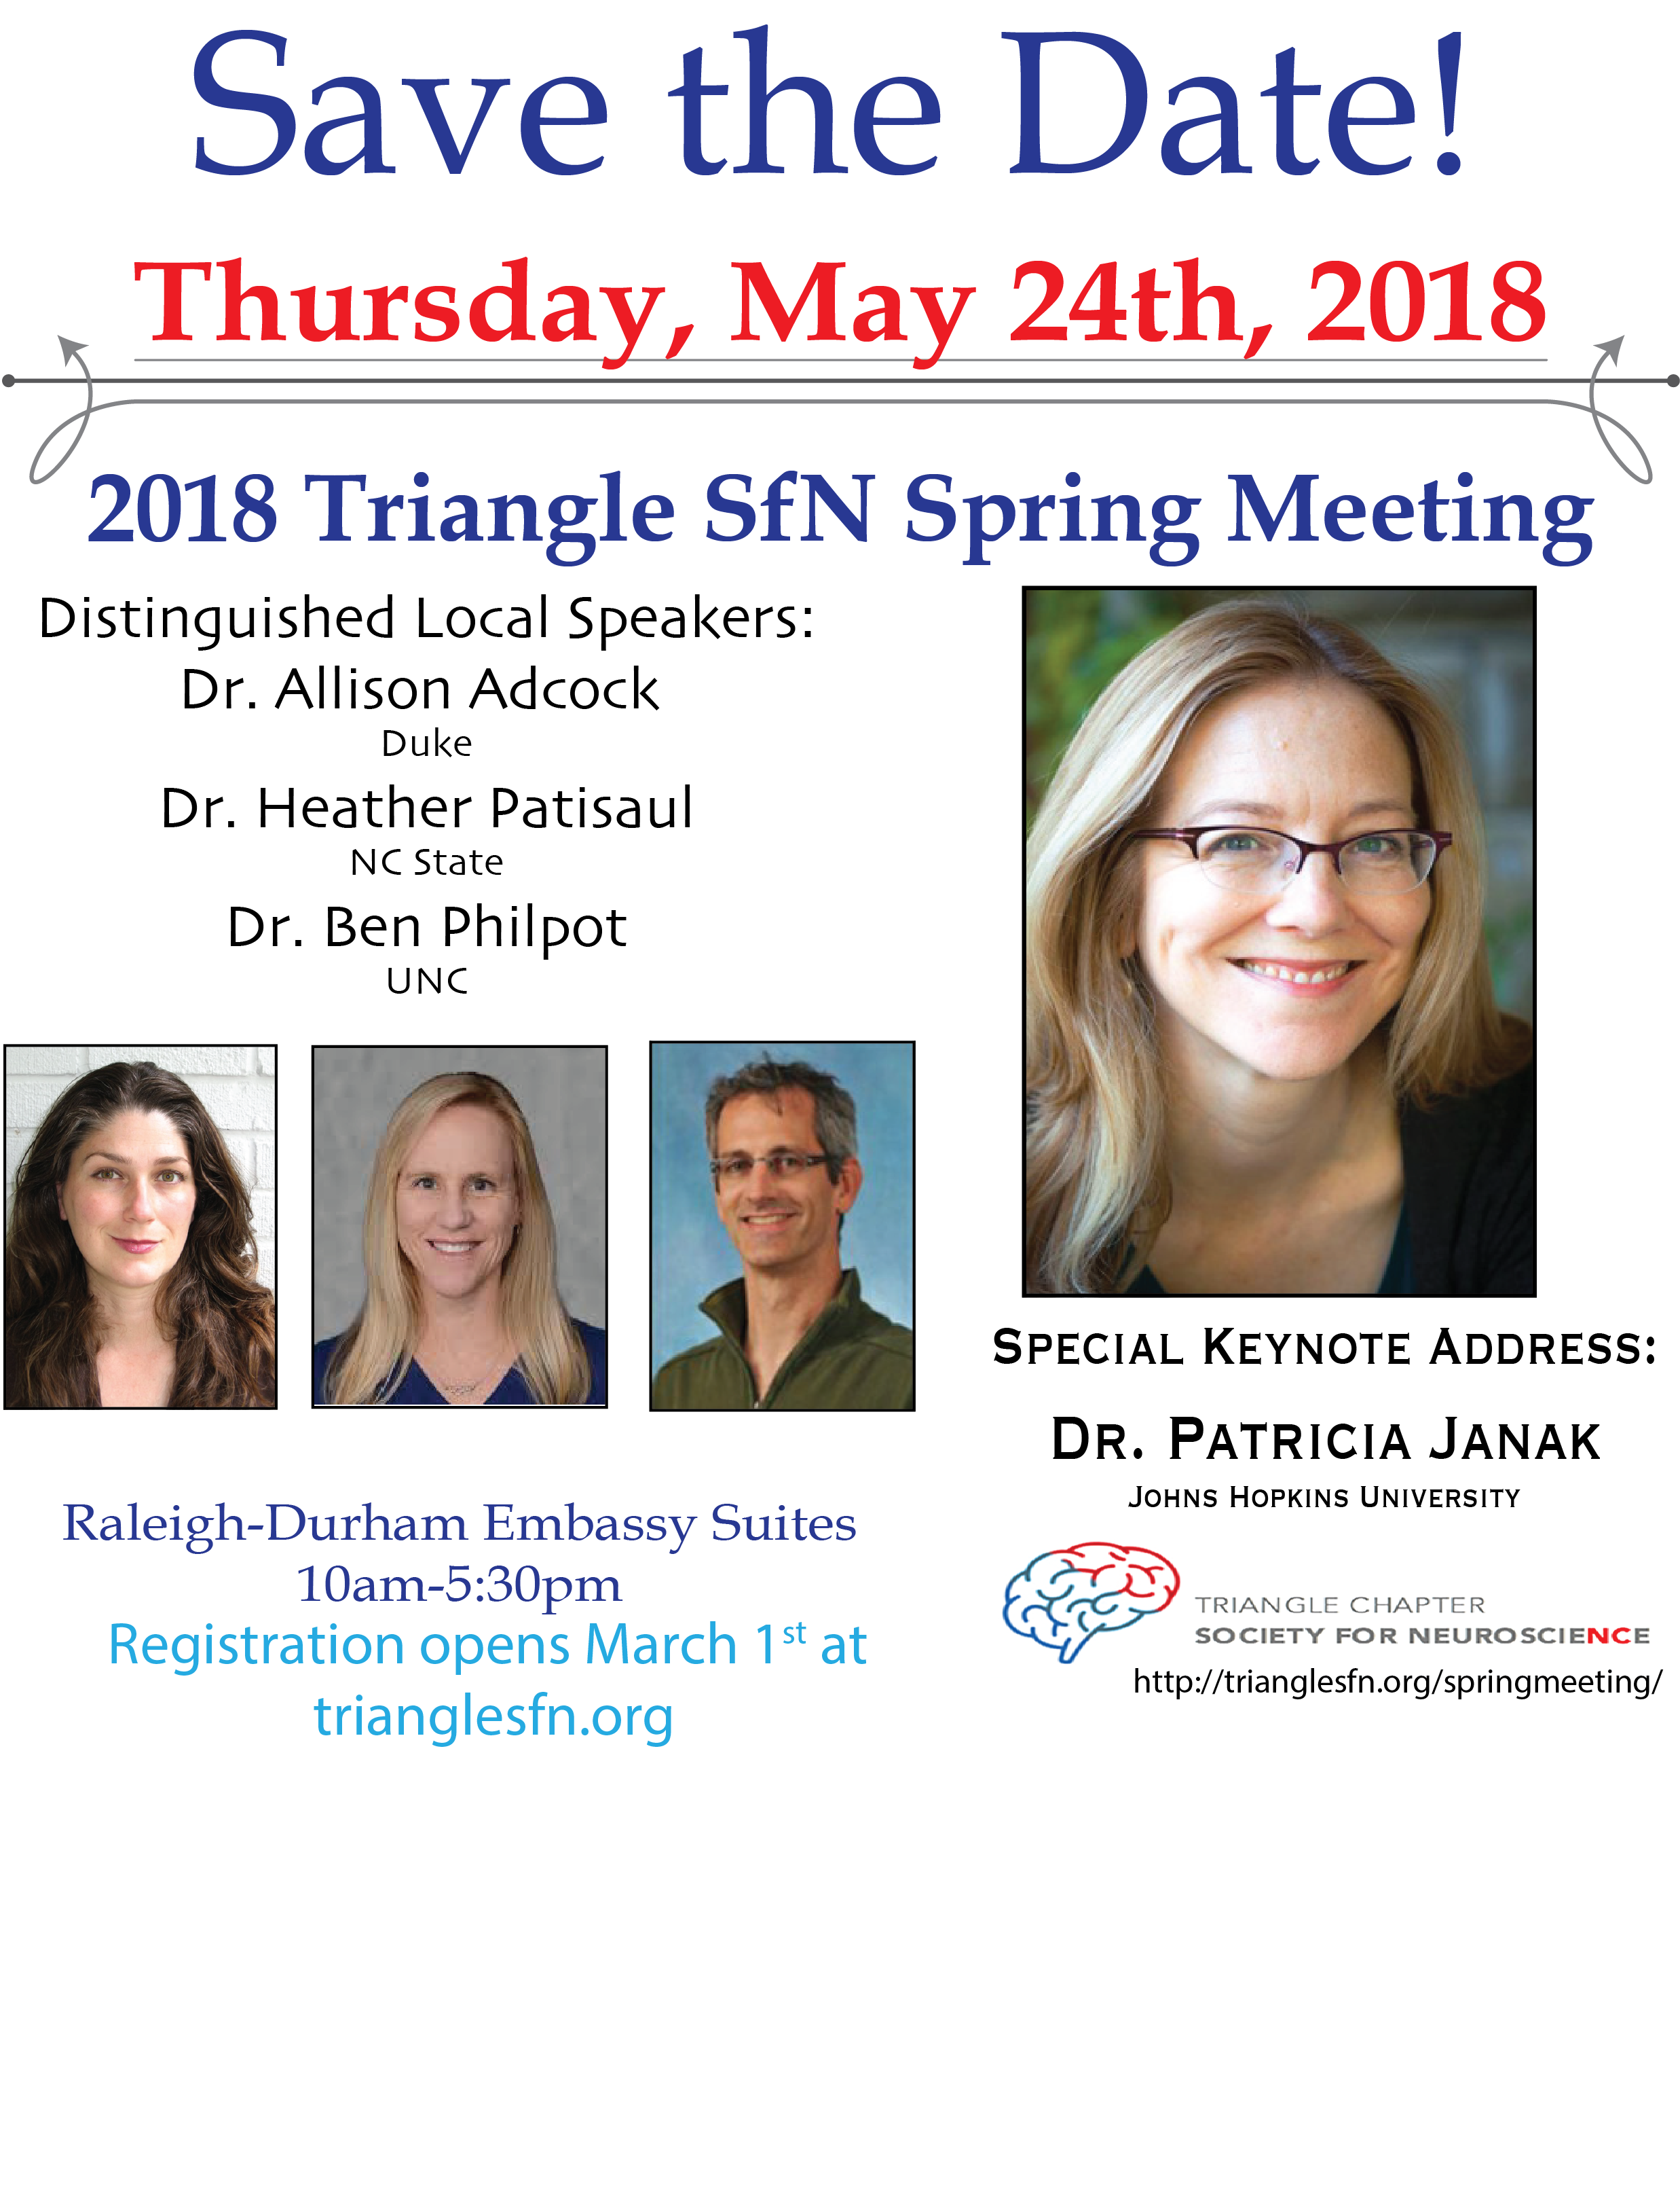

Have an event you’d like to promote? Send an email to trianglesfnnews@gmail.com to have your event added to our calendar at http://trianglesfn.org/calendar-of-event

Save the Date!

Triangle SfN Spring Neuroscience Meeting
The Triangle Chapter of the Society for Neuroscience is delighted to announce its 4th Annual Spring Neuroscience Meeting, which will be held on Thursday, May 24, 2018 at the Embassy Suites in RTP from 10 AM - 5:30 PM. This one-day meeting aims to bring together the community of neurobiologists in the Triangle and highlight their latest research.
This year’s conference features talks by three outstanding local neuroscientists. Dr. Alison Adcock, an Associate Professor of Psychiatry and Behavioral Sciences and an Associate Professor of Neurobiology at Duke University, uses human brain imaging to measure how changes in brain activity relate to both motivation and memory. Dr. Heather Patisaul, a Professor in the Department of Biological Sciences at NC State University, works to elucidate how endocrine-disrupting chemicals impact sexually dimorphic neuroendocrine pathways and behaviors. Finally, Dr. Ben Philpot, a Professor in the Department of Cell Biology and Physiology at the University of North Carolina at Chapel Hill and an Associate Director of the UNC Neuroscience Center, investigates the molecular, cellular, and neural circuitry mechanisms underlying neurodevelopmental disorders, with the goal of discovering novel therapeutic opportunities.
In addition to the presentations by the leading local neurobiologists, the meeting’s keynote address will be delivered by Dr. Patricia Janak, a Bloomberg Distinguished Professor in the Department of Psychological and Brain Sciences and the Solomon H. Snyder Department of Neuroscience at Johns Hopkins University. The Janak laboratory investigates the behavioral and neurobiological mechanisms underlying adaptive and maladaptive associative learning. By using animal models of learning and addiction together with in vivo electrophysiology and optogenetics, Dr. Janak hopes to apply her findings to better understand how drug- and alcohol-associated stimuli contribute to relapse.
This year’s conference will also feature two poster sessions for undergraduate, graduate students and postdocs to present their latest research, as well as an opportunity for graduate students to have lunch with Dr. Janak. All other attendees will have the opportunity to network and engage in roundtable discussions over lunch. The event will conclude with a networking reception.
Registration is FREE (and includes boxed lunch) but REQUIRED as space is limited. Abstract submissions are welcome from all universities, government institutions, and pharmaceutical companies throughout the greater Triangle Region.
- Drs. Kati Healey (Duke) and Irina Evsyukova (NIEHS)
Registration and abstract submission will March 1, 2018 on www.trianglesfn.org.

Registration is FREE and REQUIRED, and includes boxed lunch.

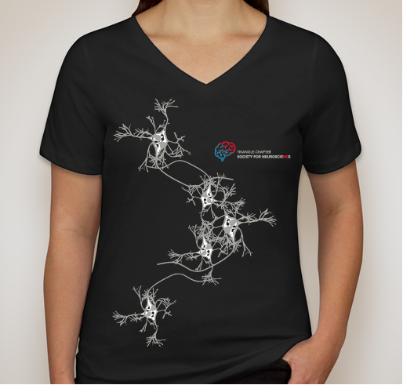
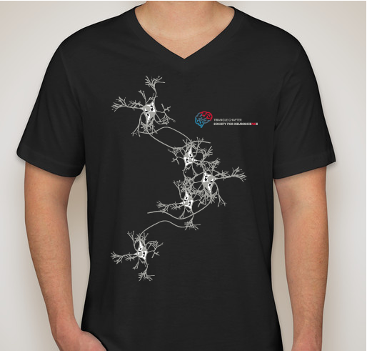
Women’s
Men’s
Show your support for Triangle SfN with this stylish neuron T-shirt! Available in men’s and women’s sizes.
T-shirts cost $18.
To order, please fill out this form: http://goo.gl/forms/wYO3ubCyieVou4M53

NORTH CAROLINA TRIANGLE CHAPTER SOCIETY FOR NEUROSCIENCE
MEMBERSHIP INFORMATION
Annual Dues:

Order Your Triangle SfN T-Shirt!
Membership in Triangle SfN does not require membership in National SfN
Regular Membership: $20.00/year or $50.00/3 years
Student Membership: $5.00/year or $12.00/3 years
Partner Membership: $25.00/year or $60.00/3 years

TO RENEW OR MANAGE YOUR MEMBERSHIP, VISIT US ONLINE AT
www.trianglesfn.org

Keep in Touch!
Website: http://www.trianglesfn.org

General questions and comments: TriangleSfNChapter@gmail.com
Communications committee:
TriangleSfNNews@gmail.com

Twitter: @Triangle_SfN
Facebook Page: facebook.com/TriangleSfN/

Facebook Group: facebook.com/groups/trianglesfn

LinkedIn: Society for Neuroscience Triangle Chapter

Facebook: facebook.com/groups/trianglesfn

LinkedIn:
Society for Neuroscience Triangle Chapter

Website: http://www.trianglesfn.org

